 |  |  |  |  |  |  | No. |  |  |  |  |  |  |  |  |  |  |  |  |  | 129
SERIAL NO.: | 44-40371 |  |  |  |  |  | MOST POPULAR NOSE ART NAME: |  |  |  |  | “SILVER LADY”
MODEL: | B-24J-160-CO |  |  |  |  |  | MFR: | Consolidated-San Diego
 |  |  |  |  |  |  | CONTRACTOR'S NO.: |  |  |  |  |  |  |  |  | 4307
INITIAL MFG DATE: |  |  | 03/16/1944 |  |  |  | MFG COMPLETION DATE: |  |  |  |  |  |  |  |  |  |  |  | 03/22/1944
FIRST FLIGHT DATE: |  |  |  |  | 03/24/1944 |  | MOD CENTER DATE: |  |  |  |  |  |  |  | 03/28/1944
 |  |  |  |  |  |  | MOD CENTER PLACE: |  |  |  |  |  |  |  | Tucson
USAAF ACCEPTANCE DATE: |  |  |  |  |  | 03/27/1944
TO STAGING AREA DATE: |  |  |  |  |  | 04/24/1944 | STAGING PLACE: |  |  |  |  |  |  |  | Hamilton Field, CA
OVERSEAS FLIGHT DATE: |  |  |  |  |  | 05/05/1944 | DEPARTURE PLACE: |  |  |  |  |  |  |  | Fairfield, CA
OVERSEAS ARRIVAL DATE: |  |  |  |  |  | 05/09/1944 | DESTINATION: |  |  |  | Townsville
MOD COMPLETED
OVERSEAS: |  |  |  |  |  |  | OVERSEAS MOD PLACE:
ASSIGNMENT: |  | 380/530 |  |  |  |  | ASSIGNMENT
 |  |  |  |  |  |  | DATE: |  |  | 07/1944
STATION: |  | Fenton
FIRST MISSION: |  | 06/08/1944 |  |  |  |  | WHERE (1ST MISSION): |  |  |  |  |  |  |  | Jefman
NO. OF MISSIONS: |  | 42 - AUS |  |  |  |  | TERMINATION DATE: |  |  |  |  |  |  |  | 09/28/1945
WHY TERMINATED: |  |  |  | Salvaged
WHERE TERMINATED: |  |  |  | Clark, The Philippines
STRICKEN OFF CHARGE: |  |  |  | 10/11/1946 |  |  | WHERE REMOVED: |  |  |  |  |  | UCIP

NOTES:

Serial No.: | 44-40371 |  | Nose Art: | “SILVER LADY”
Model: | B-24J-160-CO

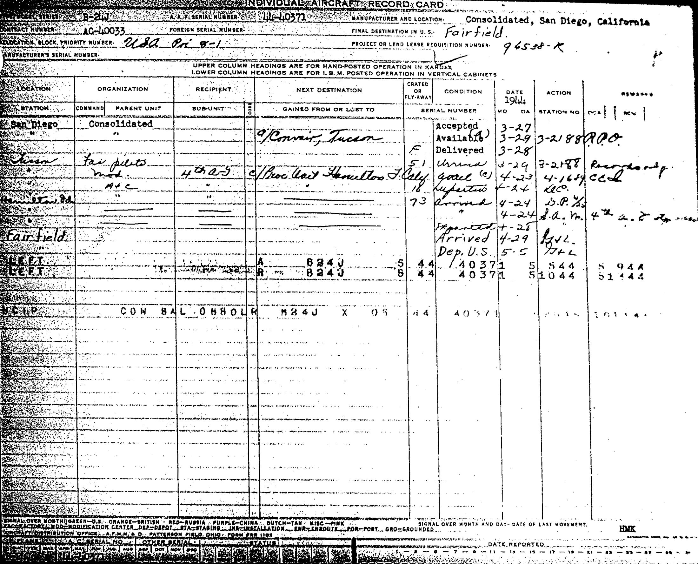

Serial No.: | 44-40371 |  | Nose Art: | “SILVER LADY”
Model: | B-24J-160-CO

 | SSN | Rank | Name
Crew Chief(s): | 35380650 | S/Sgt | William L. Miller

 | SSN | Rank | Name
Mechanic(s): |  |  | Not Available in Current Records

Notes:

“SILVER LADY”
Serial No.: 44-40371 Model: B-24J-160-CO

Right Side

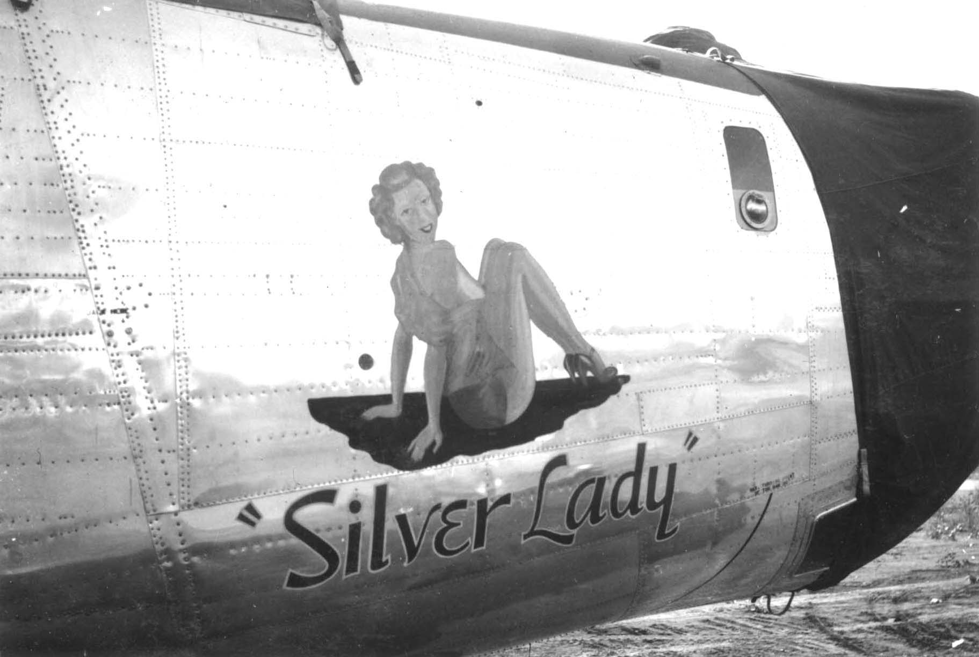

Source: Joe Dally Collection.

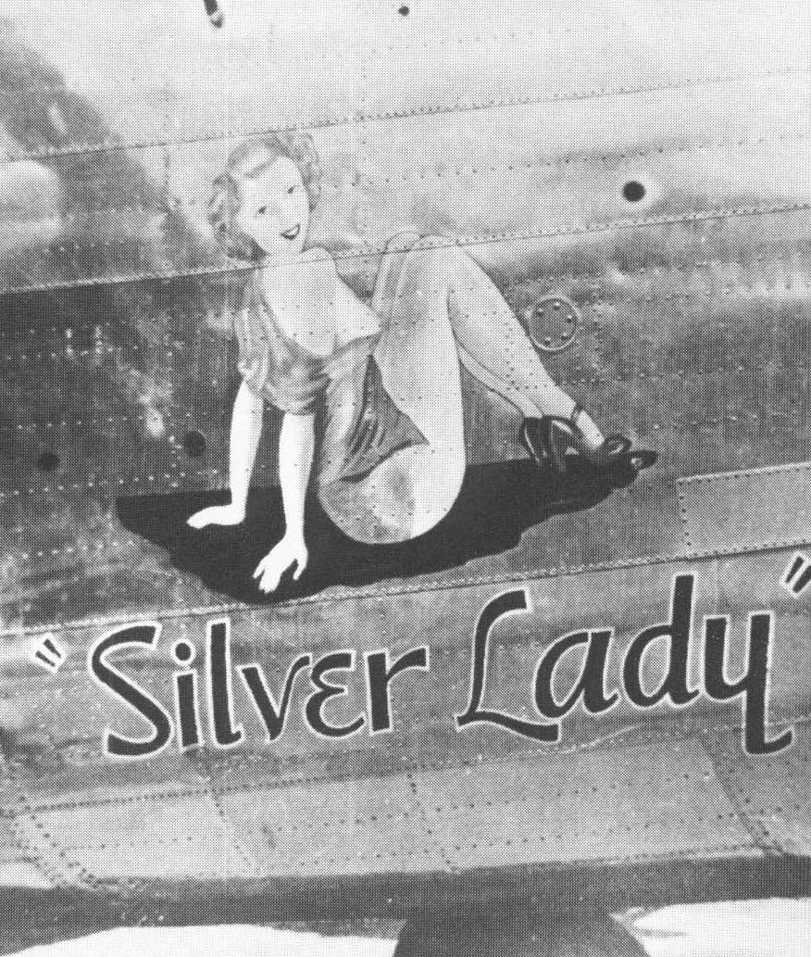

Source: Horton/Horton, King of the Heavies, p. 152.

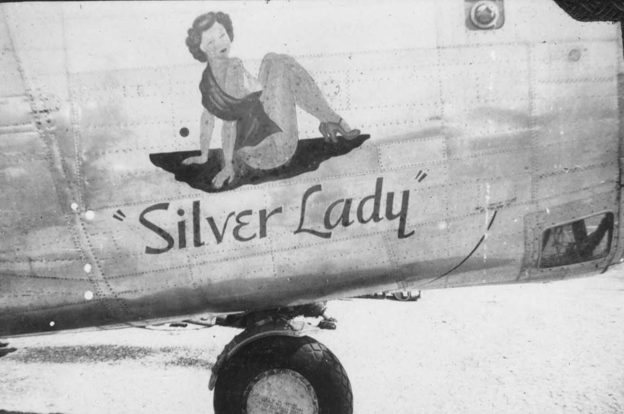

Source: Pete Burris Collection.

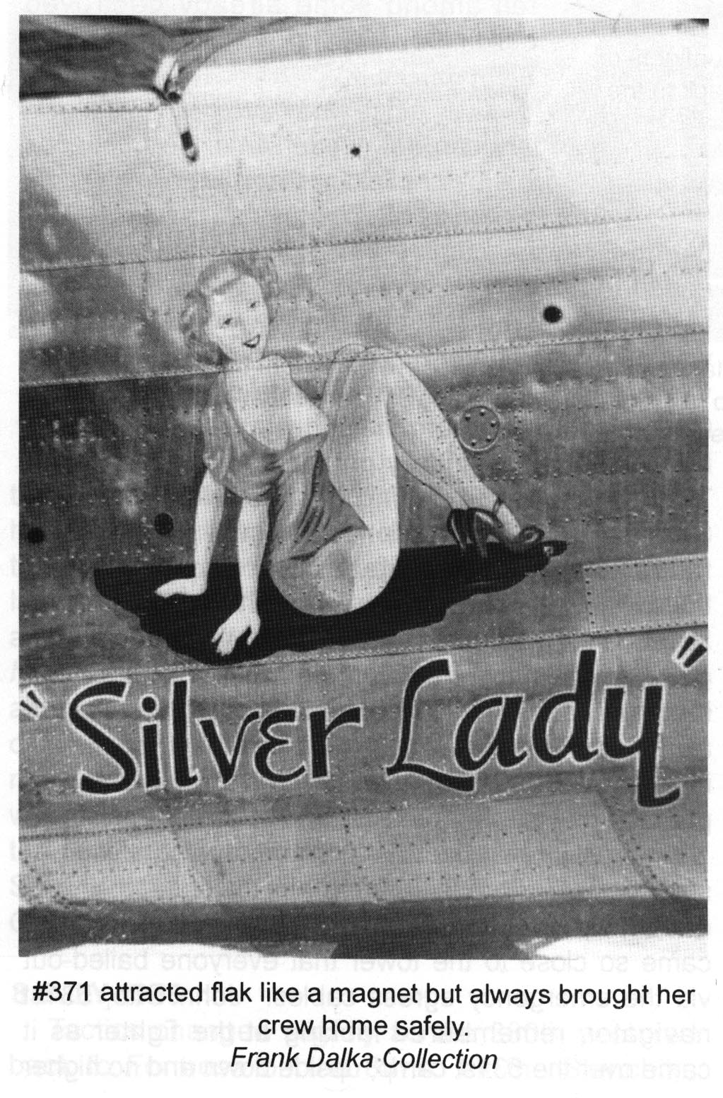
Source: Horton, Best in the Southwest, p. 393.

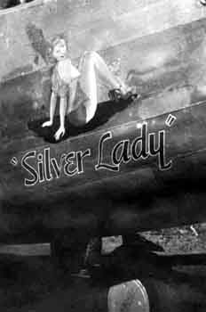

Source: http://www.b24bestweb.com/silverlady1.htm

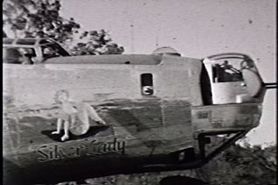

Source: Gossard/Frye Videotape.

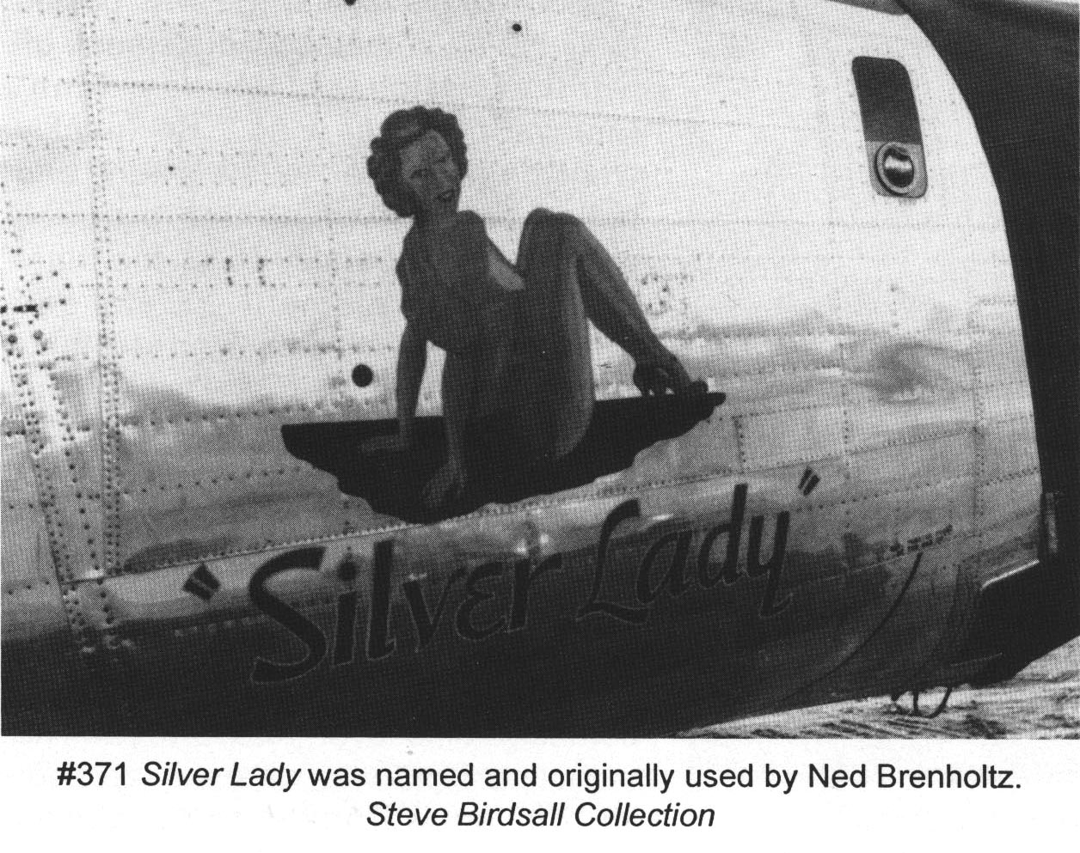
Source: Horton, Best in the Southwest, p. 273.

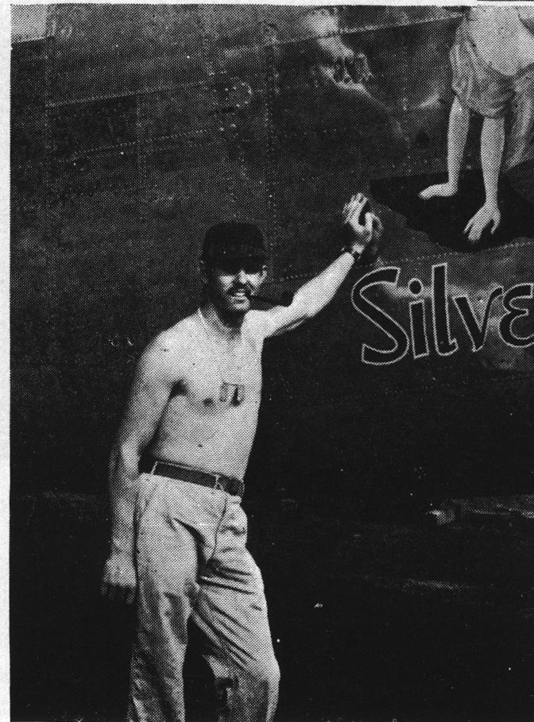

Source: The Flying Circus, p. 151.

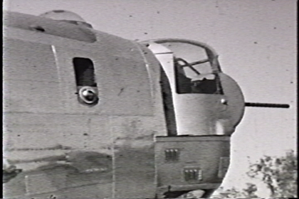

Source: Gossard/Frye Videotape.

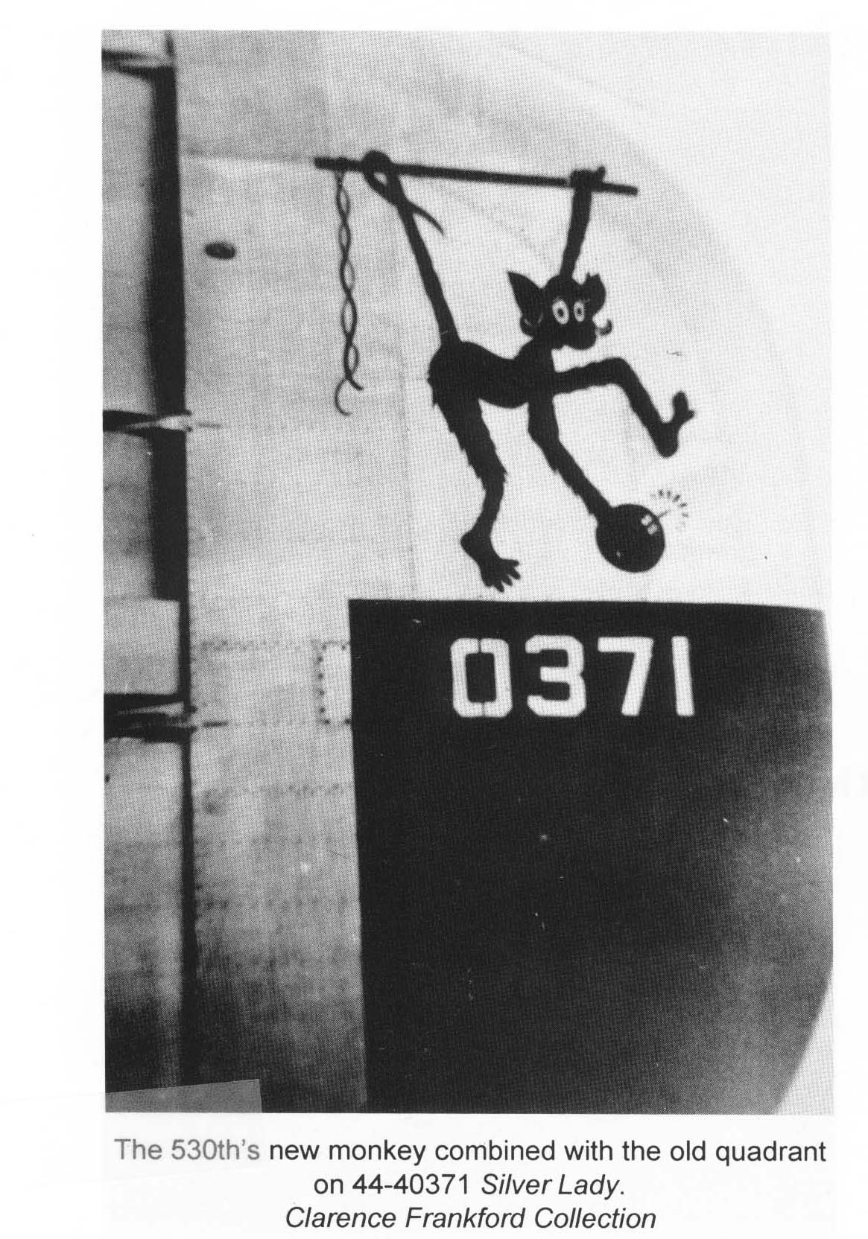
Source: Horton, Best in the Southwest, p. 442.

Left Side

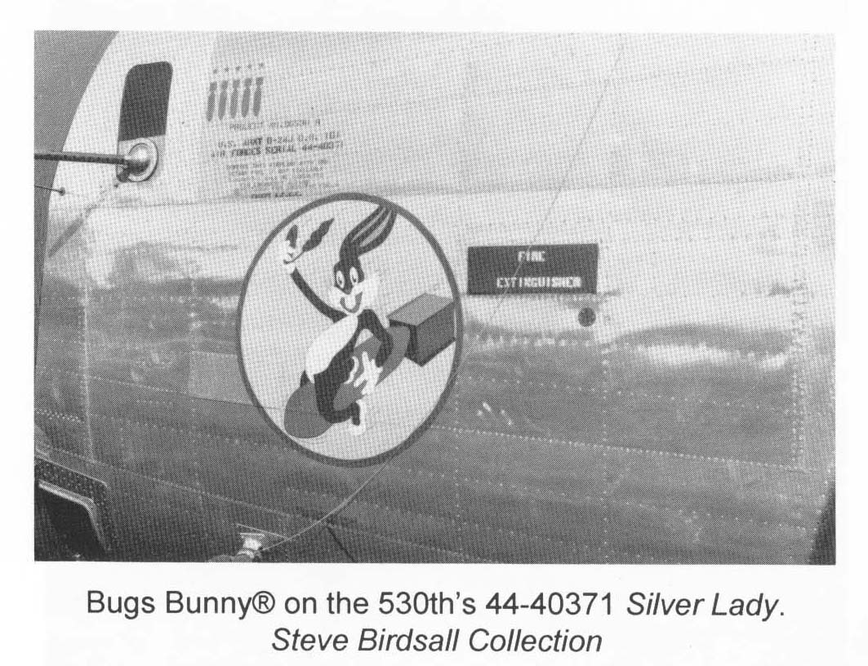
Source: Horton, Best in the Southwest, p. 440.

SN | 44-40371 |  |  | Nose Art |  | “SILVER LADY” |  | Model |  | J-160-CO
Sqdn Assgd |  | 530 |  | Mfr | Consolidated-San Diego |  |  | M# | 371

LOCATION: | Australia

NOTES:

 | No. | Date  (M/D/Y) | Mission  # | Mission Type | Target | Crew # | Acft Cmdr | Sqdn | Results/NOTES
 | 1 | 06/08/1944 | FEN VII-32 | Strike | Shipping, Jefman | 60 | Brenholtz | 530
 | 2 | 06/12/1944 | FEN VII-33 | Strike | Liang | 55 | Rayment (RAAF) | 530
 | 3 | 06/22/1944 | FEN VII-38 | Strike | Liang | 60 | Brenholtz | 530
 | 4 | 06/27/1944 | FEN VII-43 | Strike | Babo | 55 | Rayment (RAAF) | 530
 | 5 | 06/29/1944 | FEN VII-45 | Strike | Babo | 56 | Frecker (RAAF) | 530
 | 6 | 07/04/1944 | FEN VIII-8 | Strike | Amahai | 59 | Black | 530
 | 7 | 07/09/1944 | FEN VIII-16 | Strike | Namlea | 52 | Cesario | 530
 | 8 | 07/17/1944 | FEN VIII-24 | Strike | Maomere, Flores | 70 | White (RAAF) | 530
 | 9 | 07/24/1944 | FEN VIII-40 | Recce | Shipping, Banda Sea | 70 | White (RAAF) | 530

SN | 44-40371 |  |  | Nose Art |  | “SILVER LADY” |  | Model |  | J-160-CO
Sqdn Assgd |  | 530 |  | Mfr | Consolidated-San Diego |  |  | M# | 371

LOCATION: | Australia

NOTES: | Mission 13: Special Missions-Australia

 | No. | Date  (M/D/Y) | Mission  # | Mission Type | Target | Crew # | Acft Cmdr | Sqdn | Results/NOTES
 | 10 | 07/27/1944 | FEN VIII-45 | Strike | Laha | 72 | Hirst (RAAF) | 530 | First Mission for this Crew
 | 11 | 07/28/1944 | FEN VIII-49 | Strike | Namlea | 56 | McDaniel | 530
 | 12 | 07/31/1944 | FEN IX-7 | Strike | Amahai | 67 | Petre | 530
 | 13 | 08/08/1944 | FEN III-61 | Search | Search for Missing B-24 | 54 | Murphy | 530
 | 14 | 09/04/1944 | FEN X-9 | Strike | Kendari | 56 | McDaniel | 530
 | 15 | 09/09/1944 | FEN X-17 | Search I | Arafura Sea | 67 | Petre | 530
 | 16 | 09/11/1944 | FEN X-21 | Search H-1 | Banda Sea | 66 | Bayman | 530 | Planck Crew
 | 17 | 09/16/1944 | FEN X-35 | Strike | Kendari | 72 | Hirst (RAAF) | 530
 | 18 | 09/27/1944 | FEN XI-19 | Strike | Haroekoe | 61 | Jenkins | 530
 | 19 | 09/29/1944 | FEN XI-23 | Strike | Liang | 52 | Bevers | 530
 | 20 | 10/02/1944 | DAR I-4 | Strike | Macassar | 68 | Martin | 530 | Kiel Crew

SN | 44-40371 |  |  | Nose Art |  | “SILVER LADY” |  | Model |  | J-160-CO
Sqdn Assgd |  | 530 |  | Mfr | Consolidated-San Diego |  |  | M# | 371

LOCATION: | Australia

NOTES:

 | No. | Date  (M/D/Y) | Mission  # | Mission Type | Target | Crew # | Acft Cmdr | Sqdn | Results/NOTES
 | 21 | 10/05/1944 | DAR I-10 | Strike | Macassar | 70A | Cupper (RAAF) | 530
 | 22 | 10/09/1944 | DAR I-22 | Strike | Koepang | 64 | DeLoache | 530
 | 23 | 10/21/1944 | DAR II-6 | Strike | Pare Pare | 53 | Louden | 530
 | 24 | 10/25/1944 | DAR II-21 | Strike | Malili | 72A | Harrison (RAAF) | 530
 | 25 | 10/28/1944 | DAR II-30 | Strike | Macassar | 61 | Jenkins | 530 | First Mission for this Crew
 | 26 | 10/30/1944 | DAR II-36 | Strike | Macassar | 62 | Beach | 530
 | 27 | 11/02/1944 | DAR II-46 | Strike | Macassar | 67 | Petre | 530
 | 28 | 11/06/1944 | DAR III-2 | Search G-1-Red | Flores Sea | 56 | McDaniel | 530
 | 29 | 11/10/1944 | DAR III-15 | Search H-1-Red | Banda Sea | 58 | Hamrick | 530

SN | 44-40371 |  |  | Nose Art |  | “SILVER LADY” |  | Model |  | J-160-CO
Sqdn Assgd |  | 530 |  | Mfr | Consolidated-San Diego |  |  | M# | 371

LOCATION: | Australia

NOTES:

 | No. | Date  (M/D/Y) | Mission  # | Mission Type | Target | Crew # | Acft Cmdr | Sqdn | Results/NOTES
 | 30 | 11/14/1944 | DAR III-27 | Strike | Macassar | 58 | Hamrick | 530 | Abort, Engine Trouble
 | 31 | 11/21/1944 | DAR III-47 | Strike | Ambesia | 67 | Petre | 530 | Abort, Engine Trouble
 | 32 | 11/26/1944 | DAR IV-10A | Ferry | Mines to Morotai | 57 | Quinn | 530
 | 33 | 11/27/1944 | DAR IV-10B | Ferry | Return to Darwin | 57 | Quinn | 530
 | 34 | 11/28/1944 | DAR IV-18A | Ferry | Mines to Morotai | 56 | McDaniel | 530
 | 35 | 11/29/1944 | DAR IV-18B | Ferry | Return to Darwin | 56 | McDaniel | 530
 | 36 | 11/30/1944 | DAR IV-23 | Strike | Malimpoeng A/D | 70 | McKinney | 530
 | 37 | 12/02/1944 | DAR IV-25 | Strike | Boro Boro | 57 | Quinn | 530

SN | 44-40371 |  |  | Nose Art |  | “SILVER LADY” |  | Model |  | J-160-CO
Sqdn Assgd |  | 530 |  | Mfr | Consolidated-San Diego |  |  | M# | 371

LOCATION: | Australia

NOTES:

 | No. | Date  (M/D/Y) | Mission  # | Mission Type | Target | Crew # | Acft Cmdr | Sqdn | Results/NOTES
 | 38 | 12/03/1944 | DAR IV-37 | Strike | Kendari, Harass | Mix | Martin | 530
 | 39 | 12/16/1944 | DAR V-17 | Search I-2-Green | Banda and Molucca Seas | 59 | Black | 530
 | 40 | 12/26/1944 | DAR V-44 | Strike | Kendari, Harass | 55 | Planck | 530 | Thompson Crew
 | 41 | 12/31/1944 | DAR VI-14 | Strike | Kendari, Harass | 61 | Jenkins | 530
 | 42 | 01/12/1945 | DAR VIII-1 | Strike | Ampenam, Soemba | 67 | Petre | 530
 |  |  |  |  |  |  |  |  | Transfer, Mindoro, Philippines

