380th Bomb Group Association
Patches / Jackets / Caps / Visors

PATCHES  (Mark on line # requested)  Squadron/Group patches:  $10.00 ea.  Group: ___________  528th: ____________  529th: ____________  530th: ____________  531st: ____________ | 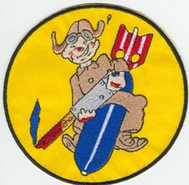  528th  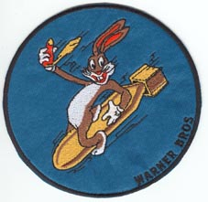  530th  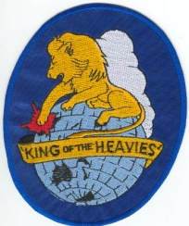  Group | 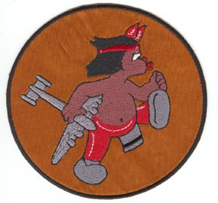  529th  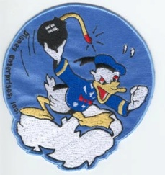  531st
Wings patches:  $3.00 ea.  Pilot: _________________  Navigator: _____________  Bombardier: ___________  Gunner: ______________  Air Crew Member: _____  RAAF: _________________ | 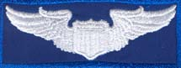  Pilot  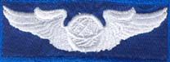  Navigator  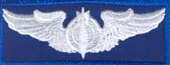  Bombardier  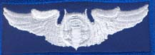  Gunner  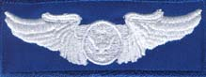  Aircrew | 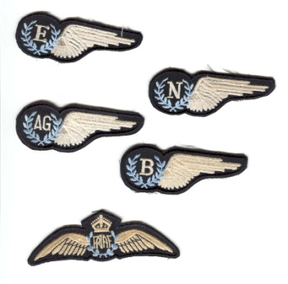  RAAF: Circle picture below to identify which one(s) you want
Shoulder patches:  $4.00 ea.  5th Air Force: ________  USAAF: ______________ | 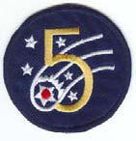  5th Air Force | 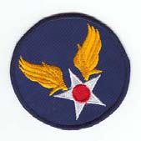  USAAF
JACKETS  Blue nylon, $25.00 ea.  (Mark on line # requested)  Small _______  Medium: ____  Large: ______  XL: ________  2XL: _______ | 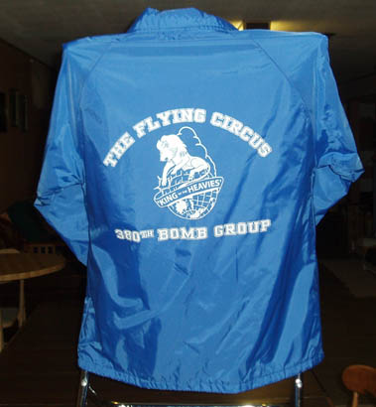 | 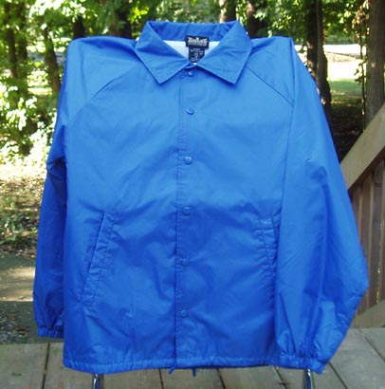
CAPS, $8.00 ea.  One size: _____ |  | 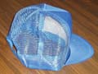
VISORS, $15.00 ea.  Pink with blue lettering ______  White with blue lettering _____ | 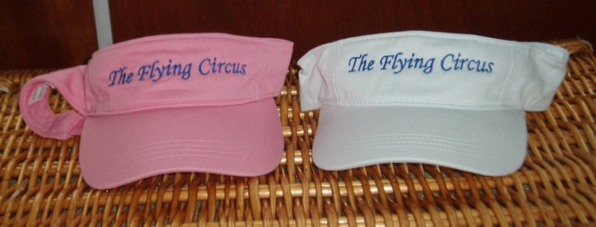
REUNION PATCHES  $3.00 ea.  Savannah/2009: _______  Tucson/2008: _______  Dayton/2007: _______  Washington/2006: ____  Older:  Year ________  Place: _____________________ | 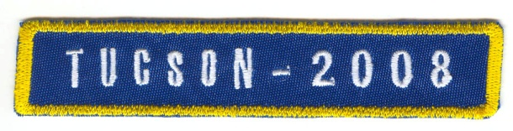  Sample reunion patch

Please see Barb Gotham to place your order.
Barbara Gotham
130 Colony Road
W Lafayette IN 47906-1209
Payable by cash or checks made payable to: 380th Bomb Group Association (no credit cards)

