PATCHES  (Mark on line # requested)  Squadron/Group patches:  $10.00 ea. (used patches $5.00 ea.)  Group: ______ 528th: ______  529th: ______ |  | 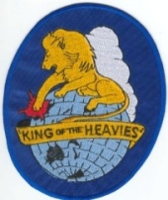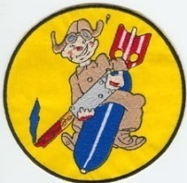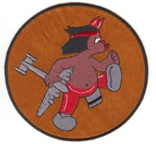  Group-6”x4-1/2”528th-5”x5” 529th-5”x5” |  |  |  |  |  | Tucson 1942-1999 patches:  FREE _______  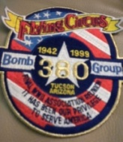 Size: 4-1/2” x 5”
Wings patches: $3.00 ea.  Pilot: _________________  Navigator: _____________  Bombardier: ___________  Gunner: ______________  Air Crew Member: _____  Size: 3-1/8” x 1-1/4” |   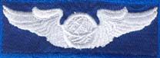   |  | Pilot  Navigator  Air Crew | 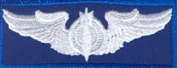  Bombardier  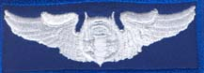  Gunner |  |  | REUNION PATCHES  FREE Size: 4-1/8” x 3/4"  Tucson/2018: _______  Older: Year ________  Place: _____________________  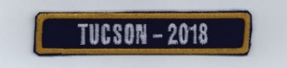
Shoulder patches:  $4.00 ea.  5th Air Force: _____  USAAF: __________  Size: 3” round | 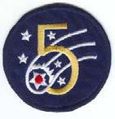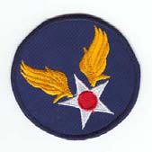  5th Air Force USAAF |  |  |  | 1981-2018 Commemorative Reunion Patch  $10.00 ea._________  Size. 3-1/2”x5-1/2” |  |  |  | 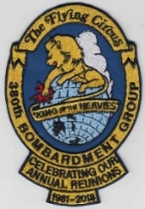
JACKETS (long sleeves) Blue nylon, $5.00 ea.  These are the only sizes left:  Unlined: Small: _____  (only 2 left) | 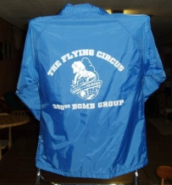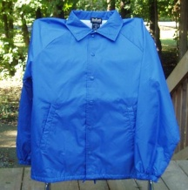  Back Front |  |  |  |  | T-shirts (short sleeves) Blue cotton/polyester,  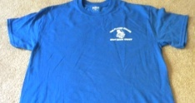  Small: ____ |  |  |  | $2.00 ea.  (Logo on shirt front only)  Front  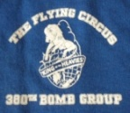  Closeup of logo on front

PLEASE send email to 380th.ww2@gmail.com before submitting order to check on current availability of items. Limited quantities of items are in stock. PATCHES WILL BE RESTOCKED AS NEEDED. HOWEVER, JACKETS, CAPS, TEES WILL NOT BE RESTOCKED. Please allow 6-10 weeks for re-stocking of patches. Allow 2 weeks for delivery. -- ADDITIONAL FUNDS FOR POSTAGE CHARGES ARE WELCOMED – HOWEVER, ADDITIONAL FUNDS REQUIRED FOR EXPRESS DELIVERY OR OVERSEAS ORDERS.

