Image copyright: [Copyright expired - public domain](http://www.awm.gov.au/copyright/#pd)

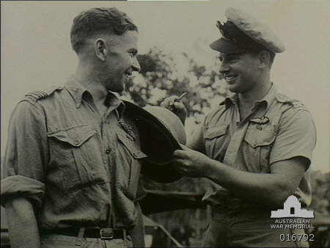

**ID number**

ID number 016792

Photographer: Short, Gordon Herbert

Date made: 1 April 1944

Two RAAF pilots, attached to 528 Liberator Squadron , Headquarters, NW Area, USAAF, (formerly 2 Squadron, RAAF Hudson aircraft pilots), 406484 Flying Officer Alan Hawkesford DFC, of Subiaco, WA (right) signing a hat and 407161 Flight Lieutenant (Fl Lt) Neil Thomson Badger DFC , of Adelaide, SA (left). Fl Lt Badger was lost on operations over Dutch New Guinea on 8 May, 1944, and has no known grave. He is commemorated on the Lae Memorial in Papua New Guinea.

http://cas.awm.gov.au/item/016792