PATCHES  (Mark on line # requested)  Squadron/Group patches:  $10.00 ea.  Group: ______ 528th: ______  529th: ______ 530th:_______  531st: _____ |  |  | 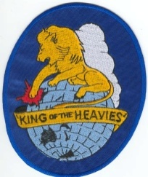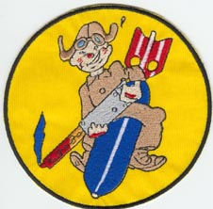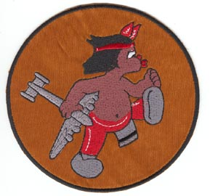  Group-6”x4-1/2” 528th-5”x5” 529th-5”x5” |  |  |  |  | 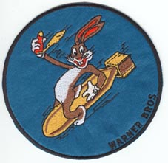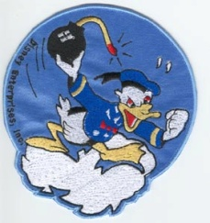  530th-4-3/4”x4-3/4” 531st – 5-1/2”x4-3/4”
Wings patches:  $3.00 ea.  Pilot: _________________  Navigator: _____________  Bombardier: ___________  Gunner: ______________  Air Crew Member: _____  Size: 3-1/8” x 1-1/4” |  |  | 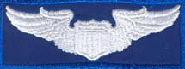  Pilot  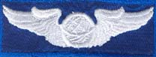  Navigator  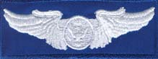  Aircrew |  |  | 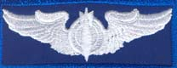  Bombardier  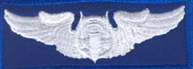  Gunner
RAAF wings patches:  $3.00 ea.  RAAF: _________________  Navigator: _____________  Bombardier: ___________  Engineer: ______________  Size: RAAF 4-1/4” x 1-1/2”  Others: 3-1/2” x 1-1/4” |  |  | 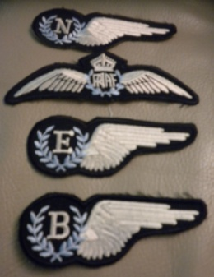 |  |  |  | Tucson 1942-1999 patches:  $3.00 ea. _________  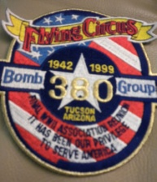 Size: 4-1/2” x 5”
CAPS, $8.00 ea.  One size: _____ | 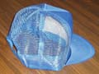 |  |  |  | REUNION PATCHES  $3.00 ea. 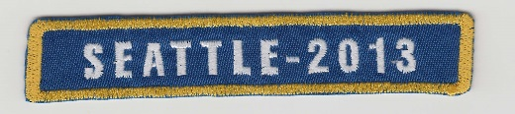  Seattle-2013:_____  Older: Year ________  Place: _____________________ |  |  |  |  | 4-1/8” x 3/4"
JACKETS (long sleeves)  Blue nylon, $25.00 ea.  (Mark on line # requested)  Small _______ Medium: ____  Large: ______ XL: ________  2XL: _______ |  | 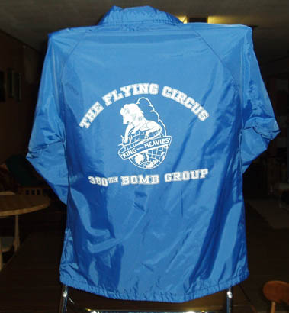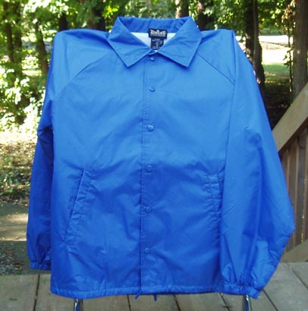  Back Front |  | T-shirts (short sleeves) - Blue cotton/polyester, $9.00 ea.  Medium: ____  Large: ______  XL: ________ |  |  |  |  | 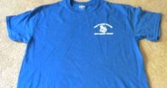  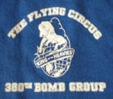 (Logo on shirt front only)

